Convocation: October 10th at 7:00pm in the Theatre of the Student Center
**You must attend convocation to sign up for your first round interview**
First Round Interviews: October 11-15
Second Round Interviews: October 20-22
HOW DO I APPLY?
Greek Ambassadors are chosen competitively each October through an interview process conducted by The Greek Ambassadors selection committee. Members of the group must also try out every year. No particular male/female ratio is established for the group. Members are required to meet the following criteria:
- Cumulative grade point average of 2.75 or higher.
- Full-time enrollment as an undergraduate (no graduate/law students).
- Involvement, but not over commitment, in campus activities.
- Ability to participate regularly in Monday night meetings, weekend and evening events.
- Willingness to memorize a volume of material about The Greek Community at The University of Alabama and to keep up with current information about its growth and development.
- Excellent oral communication skills and poise in dealing with diverse groups of individuals.
- Must comply with Greek Ambassador Guidelines
- By submitting this application, you authorize a member of the Office of Fraternity and Sorority Life staff to verify your individual student conduct record. Your acceptance into Greek Ambassadors is contingent upon your student conduct history and standing with the University.

Applications are available online at https://ofsl.sa.ua.edu/leadership/greek-ambassadors/
Please feel free to contact Greek Ambassadors at greekamb@ua.edu call the Office of Fraternity and Sorority Life at 205.348.2693 if you have any further questions.
Deadline to apply for membership is Friday, October 8 at 12 PM CST . All applications with a photograph and a one-page resume attached ​are due in 2500 Ferguson Center by 12:00 PM. No application will be accepted after the deadline.

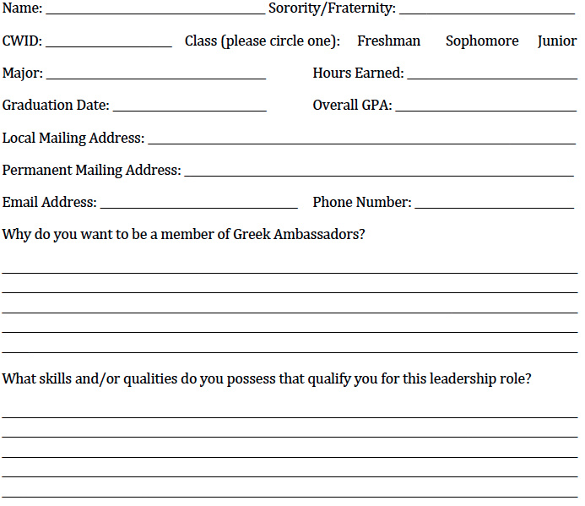
List activities and honors at The University of Alabama. Please give days and hours of club meetings and the approximate hours per week required for each activity. You must be available for mandatory Greek Ambassador Meetings every Monday from 7:30-8:30 p.m.
_______________________________________________________________________________________________________________________________________________________________________________________________________________________________________________________________________________________________________________________________________________________________________________________

Have you tried out for Greek Ambassadors before? ___________Yes ___________No

Please initial next to the following requirements. By initialing these items, you agree to them and affirm that they are correct.
______ I understand that the GPA requirement for serving as a Greek Ambassador is a minimum of 2.75 cumulative. I authorize a member of the OFSL staff to verify my grades and enrollment status at the end of each semester.
______ I authorize an OFSL staff member to check my student conduct record each semester I am an active member of Greek Ambassadors.
______ I understand I will be required to attend all training sessions, bi-weekly meetings, and all scheduled tours.
______ I understand that if selected as a Greek Ambassador, the Office of Fraternity and Sorority Life will share my personal contact information with the Office of Undergraduate admissions, for the purpose of distributing my information with families that I will be meeting in my role as a Greek Ambassador.
______ I understand I will be required to maintain active status and be a member in good standing with my chapter and national organization to serve as a Greek Ambassador.
______ I understand my chapter President will be notified of my application and will be required to submit their recommendation prior to my acceptance to the group.

