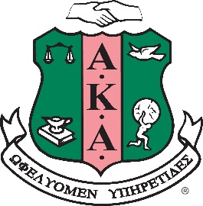

Alpha Kappa Alpha Sorority, Incorporated® - Theta Sigma Chapter
The University of Alabama
Formal Rush
Business Attire

All materials must be submitted electronically by 5 p.m. on Tuesday, February 23, 2021

In order to receive an invitation to the Virtual Formal Rush, the following requirements for membership consideration must be met:

- Have a minimum cumulative and current 2.5 GPA
- Be a full-time student during the present and prior term
- Must have creditably completed* at least one grading period as a full-time student at the University of Alabama immediately preceding submission of application;
*creditably completed is synonymous with earned full-time hours (12+ hours) in Fall 2020 semester
- Access the following forms and complete from https://aka1908.com/membership/aspiring-or-prospective-members
  - Applicant’s Pre-Rush Instructions Checklist
  - Undergraduate Membership Interest Application
  - Legacy Information and Legacy Application (if applicable)
  - Evidence of Community/Campus Involvement Forms
  - General Information for the Collegian brochure (for your file)
- Prepare the following documents and submit in the order as listed below:
  - Official letter (Enrollment Verification) from the Registrar that confirms your status as a full-time student
  - Completed Undergraduate Legacy Application (if applicable)
  - Completed Undergraduate Membership Interest Application Form
  - At least one completed Evidence of Community/Campus Involvement (ECCI) Form
  - Two (2) Letters of Reference
  - Letter of Interest
  - Copy of University student ID
- Email all of the applicable completed forms and documents listed above in a single PDF file to Robbie Washington at thetasigmaGA@gmail.com. The file name must be (your Last Name - Student ID Number).
NOTE: A signature generated with a font is not acceptable. Acceptable methods for signatures include:
  - DocuSign
  - Adobe Electronic Signatures
  - Scanned Original Signatures
- You MUST request Official Transcript be sent to the Graduate Advisor at thetasigmaGA@gmail.com to be
received by February 23rd. The email must come directly from the UA Registrar’s or the contracted vendor’s
(Credentials Solutions) email address.
- Must have attended UA NPHC Fall 2020 or Spring 2021 Convocation

Hazing does not represent the values of Alpha Kappa Alpha Sorority and will not be tolerated.

If you have any questions or concerns, contact the Graduate Advisor, Robbie Washington at (205)799-2502.

